Excel Assignment - 21

1. Write a VBA code to enter your name in A1 Cell using Input Box and once you enter the name display a message box that says the name has been entered.

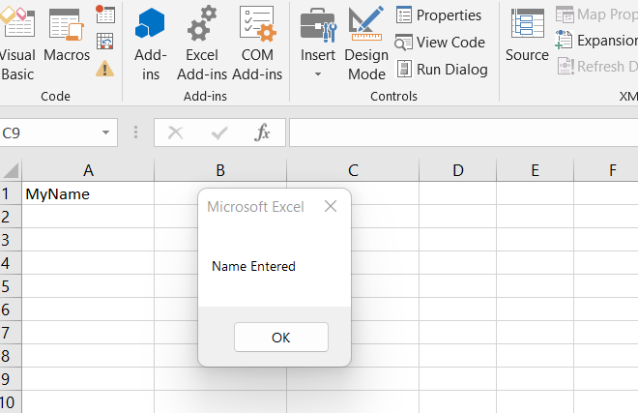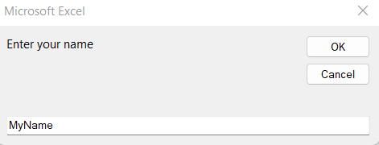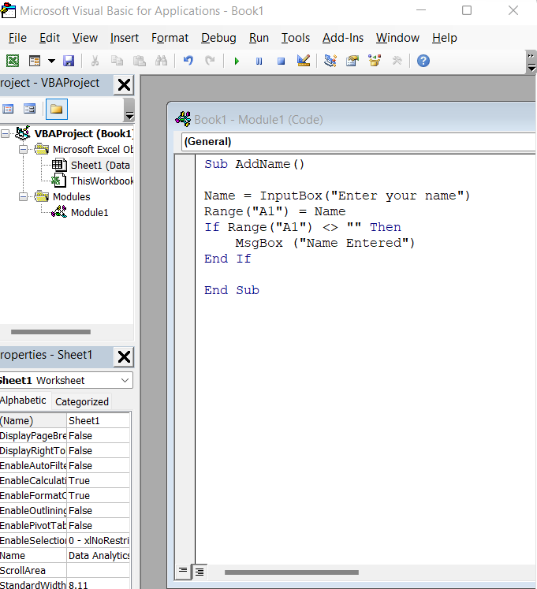

----------------------------------------------------------------------------------------------------------------------------------

1. What are Userforms? Why are they used? How to fill a list box using for loop.

Answer : A User Form is a custom-built dialog box that makes a user data entry more controllable and easier to use for the user.

A UserForm is basically a pop-up window that you can use to create a custom interface for Excel. This pop-up window allows you to have a more user-friendly interface and to automate Excel in many ways using VBA and macros.

----------------------------------------------------------------------------------------------------------------------------------

1. What is an array? Write a VBA code to enter students and their marks from the below table.

An array is a single variable with many compartments to store values, while a typical variable has only one storage compartment in which it can store only one value. Refer to the array as a whole when you want to refer to all the values it holds, or you can refer to its individual elements.

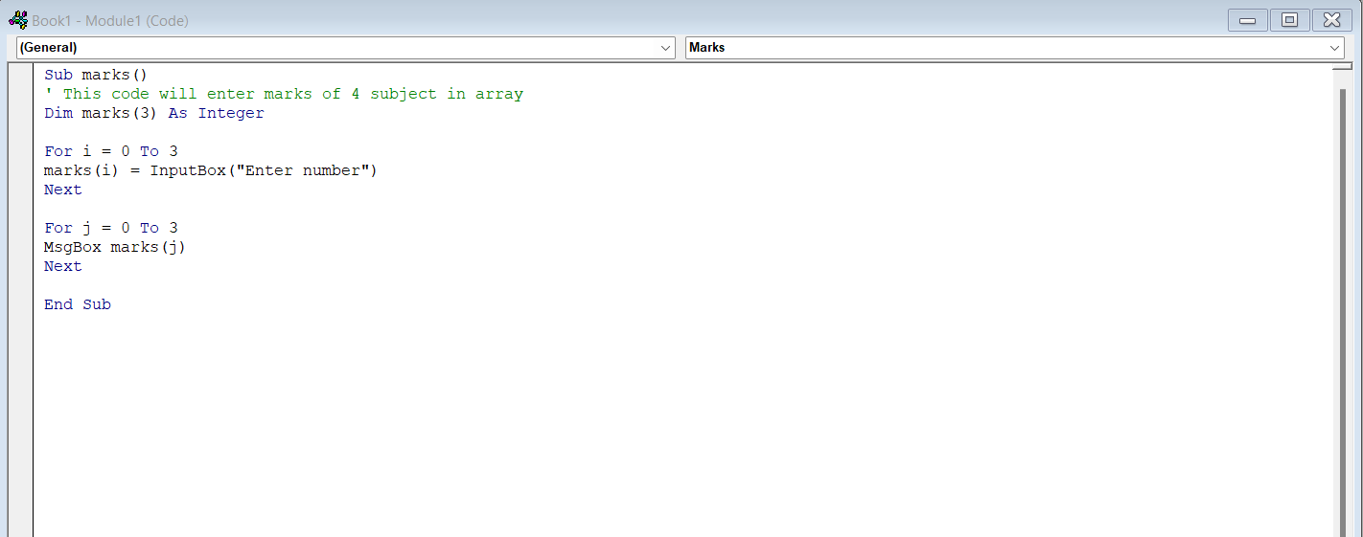

----------------------------------------------------------------------------------------------------------------------------------

4. Use the following data to create a pie chart using VBA code. Use Font - ‘Times new Roman’, Size -14, Bold, Title - Piechart’ and you are per to use colours as per your taste.

5. Check the dataset in the link given below and create a pivot table using VBA showing the sales for the year from stationary category. https://docs.google.com/spreadsheets/d/1IRSEnmgz8Ro276- GslknRNk0zlrB5CZH1YrnT71kqFM/edit?usp=sharing

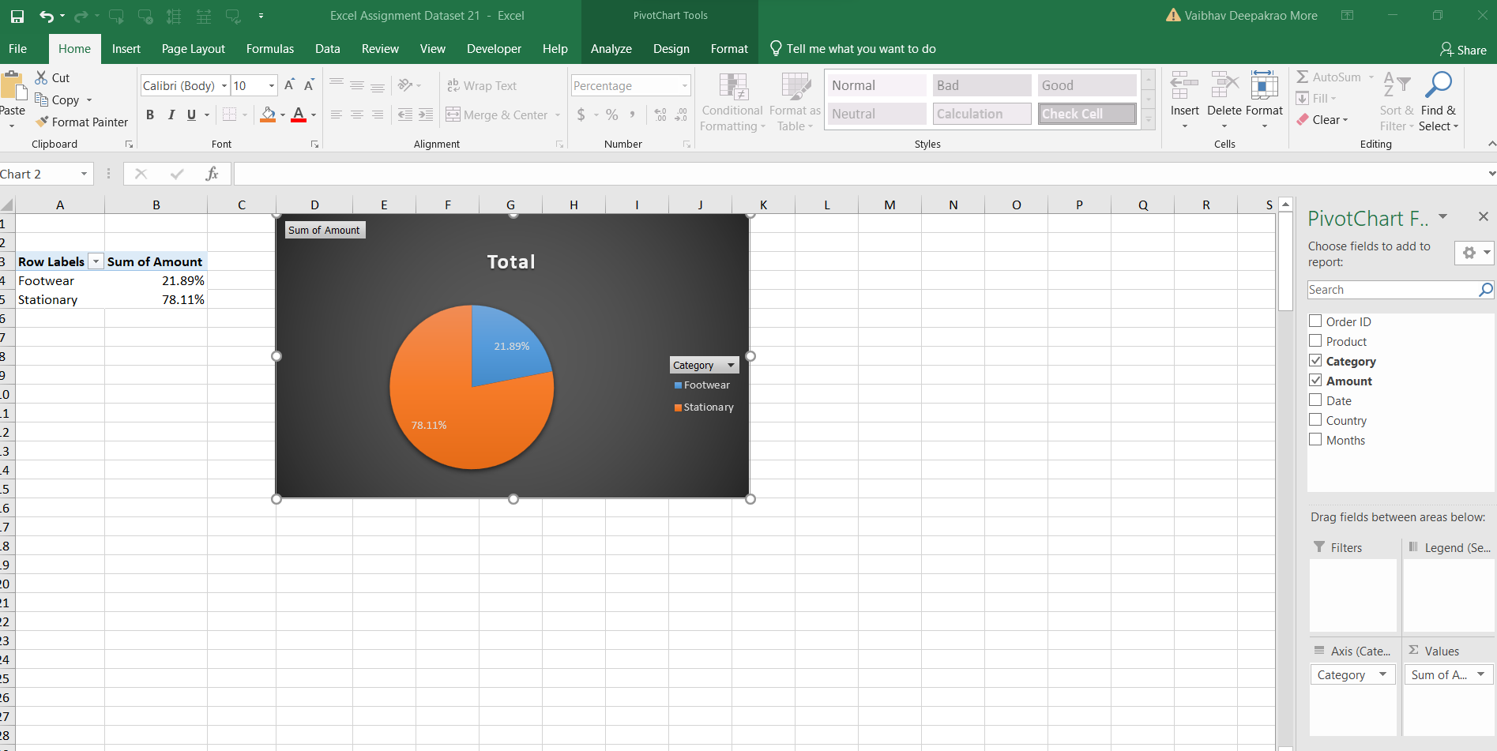 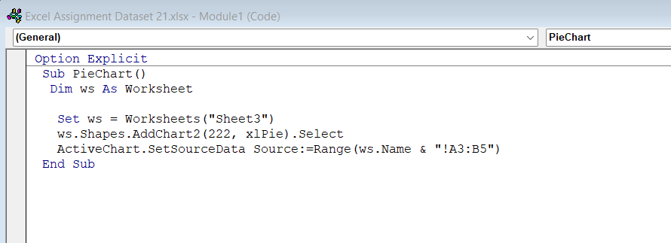

----------------------------------------------------------------------------------------------------------------------------------

6. Write step by step procedure to protect your workbook using a password.

1. Select File > Info.
2. Select the Protect Workbook box and choose Encrypt with Password.
3. Enter a password in the Password box, and then select OK.
4. Confirm the password in the Reenter Password box, and then select OK.